Case 6-Mali-Dogon-Wedding of Nommo and Nyerum on a crocodile prowed pirogue-Bronze-19th c

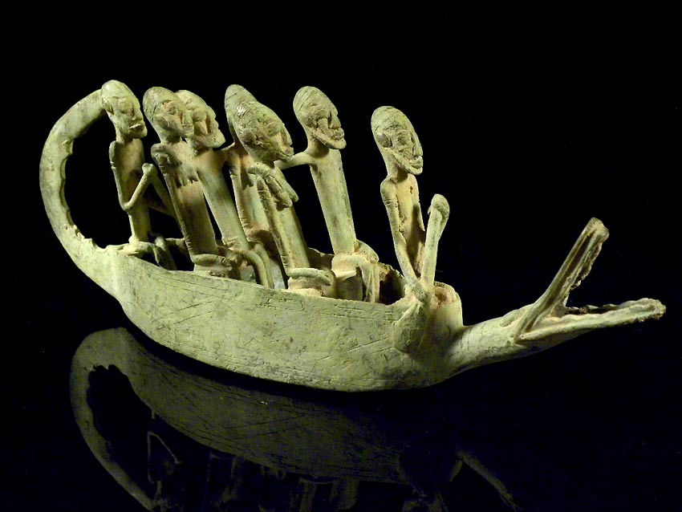

Fig. 1. Mali-Dogon-Wedding Party of Nommo and Nyerum on a crocodile-prowed pirogue-Bronze-19th c

**Case no.: 6**

**Accession Number:**

**Formal Label:** Mali-Dogon-Wedding Party of Nommo and Nyerum on a crocodile-prowed pirogue-Bronze-19th c

**Display Description:**

The benevolent crocodile totem on the prow of this pirogue protects dual wedding couples (Nyerum and Nommo) on their honeymoon journey on the Cosmic River. This is an example of obtuse Dogon metaphoric cosmology. Water spirits (*Nommo*) were, in fact, considered to be the ancestors of the autochthonous people still living in the Bandiagara Escarpment, i.e., the Tellem.They were called "Binu" which was a personal, familial nick-name, because they were, in fact, ancestors of the Dogon family.

**LC Classification:** DT551.42

**Date or Time Horizon:** 19th c

**Geographical Area:** site of Djenné-Djeno, Mali, on the flood plain of the Bani River,3 km (1.9 mi) s of modern town.

**Map:**

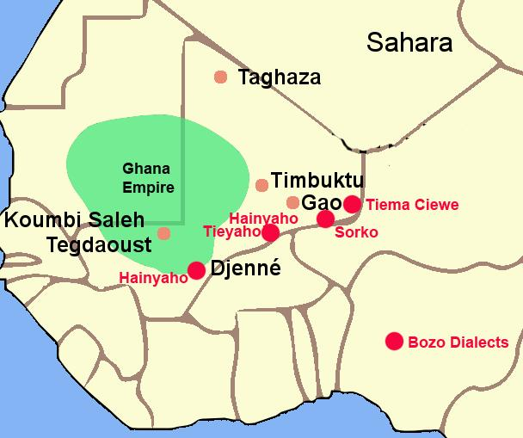

Fig. 3. The Ghana Empire 1000-1400 CE showing the ethnolinguistic groups along the Niger River. After <https://i.pinimg.com/564x/c6/a7/9b/c6a79b7443105f363ff965ebf420b7fd.jpg>

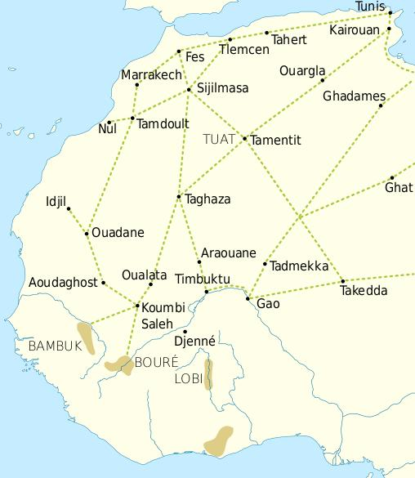

Fig. 4. Trade routes of the Western Sahara c. 1000-1500. Goldfields are indicated by light brown shading. After https://i.pinimg.com/564x/69/15/ce/6915ce6f4fd34025787fe59bd44f9eae.jpg

This trade resulted in an increasing surplus that helped expand urban centers such as Gao, Timbuktu and Djenné.

**GPS coordinates:** Djenné-Djeno, Mali: [13°53′26″N 4°32′25″W](https://tools.wmflabs.org/geohack/geohack.php?pagename=Djenn%C3%A9-Djenno&params=13_53_26_N_4_32_25_W_region:ML_type:landmark_source:dewiki)

**Cultural Affiliation:** Dogon

**Medium:** Bronze

**Dimensions:**

**Weight:**

**Condition: original**

**Provenance:** Djenné-Djeno, Mali:

**Discussion:**

An ancient Dogon myth of the world before the appearance of death described elders as becoming too old. When they reached this age they would change themselves into a large water being, a Nommo, like a crocodile/ Then they would dwell in ponds and rivers and begin a new life, helping maintain the source of water for their descendants. Meanwhile, Nyerum, the female counterpart and Cosmic consort of Nommo would enforce the social responsibilities of the Dogon People for protecting the water sources that Nommo has created.

**References:**

Bouju, Jacky. 2003. The spirit of water: in the Dogon world, *Leonardo* (MIT Press)*,* 36(4): 279-280

Bouju, Jacky. 1991. Comments. In: Van Beek, Walter. “Dogon restudied: A field evaluation of the

work of Marcel Griaule,” *Current Anthropology* 32, 2: 139-168. S. 159-160.

Bouju, Jacky. 1984. *Graine de l'homme, enfant du mil*. Sociétés Africaines, 6. Paris:

Société d'Ethnographie.

Calame-Griaule, Geneviève. 1968. *Dictionnaire dogon. Dialecte Toro. Langue et*

*civilisation.* Langues et littératures de l’Afrique Noire, Bd. 4. Paris: Klincksieck.

Calame-Griaule, Geneviève/ 1987 [1965]. *Ethnologie et langage. La parole chez les Dogon.* Paris: Institut d’Ethnologie.

Calame-Griaule, Geneviève. 1991. “On the Dogon restudied,” *Current Anthropology* 32,5: 575-577.

Dieterlen, Germaine. 1941. *Les âmes des Dogons*. Paris: Institut d’Ethnologie.

Dieterlen, Germaine.1982. *Le titre d'honneur des Arou. Dogon, Mali*. Mémoires de la Société des

Africanistes. Paris: Société des Africanistes.

Dieterlen, Germaine. 1989. “Masks and mythology among the Dogon,” *African Arts* 22,3: 34-43.

Douglas, Mary. 1967. “If the Dogon…,” *Cahiers d’Études Africaines* 7,4: 659-672.

Douglas, Mary. 1968. “Dogon culture – profane and arcane,” *Africa* 38: 16-25.

Griaule, Marcel. 1938. *Masques dogons*. Paris: Institut d’Ethnologie.

Griaule, Marcel. 1948. Valeur symbolique du vêtement Dogon. *Revue d’esthétique* 1: 195.

Griaule, Marcel. 1975 [1948]. *Dieu d’eau. Entretiens avec Ogotemmêli*. Paris: Fayard.

Griaule, Marcel. 1980 [1970]. *Schwarze Genesis. Ein afrikanischer Schöpfungsbericht.* Frankfurt:

Suhrkamp (dt. Übers.von *Dieu d’eau. Entretiens avec Ogotemmêli* 1975).

Griaule, Marcel und Germaine Dieterlen 1965. *Le renard pâle*. Paris: Institût d’Ethnologie.

Jolly, Eric. 2003. *Le pouvoir en miettes. Récits d'intronisation d'un hogon. Pays dogon, Mali.*

Classiques Africains, 29. Paris: Classiques Africains.

Jolly, Eric. 1998-99. « Chefs sacrés, chefs de guerre, deux pôles du pouvoir, » *Clio en Afrique* 5.

Mayor Anne, Eric Huysecom, Alain Gallay *et al*. 2005. “Population dynamics and

paleoclimate over the past 3000 years in the Dogon Country, Mali,” *Journal of*

*Anthropological Archaeology* 24: 25-61.

N’Diaye, Francine. 1971. Iconologie des poulies de métier à tisser dogon. *Objets et Mondes*

11: 355-370.

N’Diaye, Francine. 1995. *L’art du pays dogon dans les collections du Musée de l’Homme*. Zürich: Museum Rietberg.

Van Beek, Walter. 1991. “Dogon restudied. A field evaluation of the work of Marcel Griaule*,”*

*Current Anthropology* 32, 2: 139-168.

Van Beek, Walter. 1992. On myth as science fiction*. Current Anthropology* 33,2: 214-216.

Van Beek, Walter. 2003a. La vie et l’au-delà. Organisation sociale des Dogon. In: Bedaux, Rogier M.A.

und J. Diderik van der Waals (Hg.). *Regards sur les Dogon du Mali.* Leiden: Rijksmuseum voor Volkenkunde, Gent: Éditions Snoeck. S. 93-94.

Van Beek, Walter. 2003b. La religion des Dogon. In: Bedaux, Rogier M.A. und J. Diderik van der Waals (Hg.). *Regards sur les Dogon du Mali.* Leiden: Rijksmuseum voor Volkenkunde, Gent: Éditions Snoeck. S. 95-103.

Van Beek, Walter. 2005. Haunting Griaule. Experiences from the restudy of the Dogon. *History in Africa*

31: 43-68.

Van Beek, Walter und Pietke Banga 1990. The Dogon and their trees. In: David Parkin und Elisabeth

Croll. *Cultural understandings of the environment.* London: School of Oriental and

African Studies.